NutriGaze – AI-Based Fruit and Vegetable Freshness Detection System

1. PROJECT DESCRIPTION:
NutriGaze is an Artificial Intelligence-based web application designed to automatically detect whether a fruit or vegetable is Healthy or Rotten using image classification techniques.
The system uses Deep Learning and Transfer Learning (VGG16 architecture) to analyze uploaded images and classify them into predefined categories. The user interacts with the system through a web interface where they can upload an image, and the system provides:
- The name of the fruit or vegetable
- Freshness status (Healthy / Rotten)
- Prediction confidence percentage
The objective of this project is to reduce food waste, automate quality inspection, and demonstrate the practical application of AI in the agricultural and food industry.

2. OBJECTIVE OF THE PROJECT
The primary objectives of this project are:
- To build a deep learning model capable of classifying fruits and vegetables.
- To identify whether the product is healthy or rotten.
- To develop a user-friendly web application for real-time prediction.
- To implement Transfer Learning using a pre-trained CNN model (VGG16).
- To achieve high accuracy using a well-structured dataset.

3. ABOUT THE DATASET
Dataset Name:
Fruit and Vegetable Disease – Healthy vs Rotten Dataset
Dataset Description:
The dataset contains images of various fruits and vegetables categorized into two conditions:
- Healthy
- Rotten
Each fruit and vegetable type has two subcategories representing its condition.
Total Classes:
28 classes
Examples of classes:
- Apple – Healthy
- Apple – Rotten
- Banana – Healthy
- Banana – Rotten
- Mango – Healthy
- Mango – Rotten
- Tomato – Healthy
- Tomato – Rotten
(and more)
Image Size:
All images were resized to 224 x 224 pixels to match the input requirements of the VGG16 model.
Data Preprocessing Steps:
- Image resizing
- Pixel normalization
- Label encoding
- Train-validation split

4. ABOUT THE MODEL AND METHOD USED
Model Used:
VGG16 (Visual Geometry Group 16-layer Network)
VGG16 is a pre-trained Convolutional Neural Network trained on the ImageNet dataset. It is widely used for transfer learning tasks.

Why Transfer Learning?
Instead of training a deep neural network from scratch, transfer learning allows us to:
- Use pre-trained weights from large datasets (ImageNet)
- Reduce training time
- Improve accuracy
- Avoid overfitting

Model Architecture:
- Base Model: VGG16 (without top layers)
- Added Layers:
  - Global Average Pooling
  - Dense Layer
  - Dropout Layer
  - Output Layer (Softmax with 28 classes)

Training Details:
- Optimizer: Adam
- Loss Function: Categorical Crossentropy
- Metrics: Accuracy
- Epochs: 10
- Batch Size: Defined during training
- Image Size: 224 x 224

Model Performance:
- Training Accuracy: Above 90%
- Validation Accuracy: Above 90%
The trained model was saved as:
healthy_vs_rotten_model.h5

5. PROJECT FLOW
The complete workflow of the project is as follows:
Step 1: Dataset Collection
Images of fruits and vegetables were collected and categorized into Healthy and Rotten classes.
Step 2: Data Preprocessing
- Images resized to 224x224
- Pixel normalization
- Dataset split into training and validation
Step 3: Model Building
- Loaded pre-trained VGG16 model
- Added custom classification layers
- Compiled model with Adam optimizer
Step 4: Model Training
- Trained model on dataset
- Monitored accuracy and loss
- Saved best-performing model
Step 5: Model Saving
- Saved trained model as .h5 file
Step 6: Web Application Development
- Developed backend using Flask
- Designed frontend using HTML and CSS
- Integrated model with Flask
Step 7: Prediction Process
When user uploads an image:
- Image is saved in uploads folder
- Image is resized and preprocessed
- Model predicts class
- Result is displayed on the webpage

6. SYSTEM ARCHITECTURE
User → Web Interface → Flask Backend → Image Preprocessing →
Deep Learning Model (VGG16) → Prediction → Result Display

7. OUTPUT IMAGES (Description Section)
Home Page
Displays project title, navigation bar, and introduction to the system.
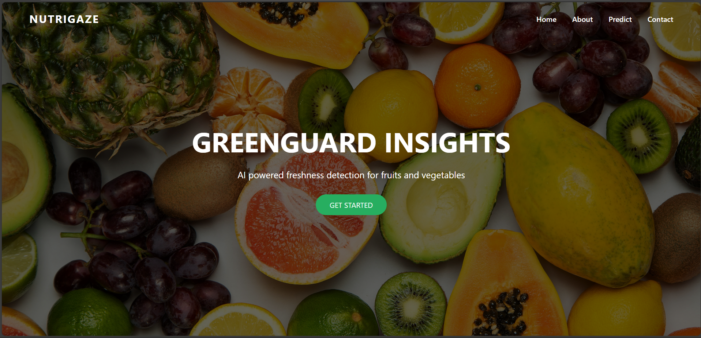
Predict Page
Allows user to:
- Upload image
- Click Predict
- View prediction results
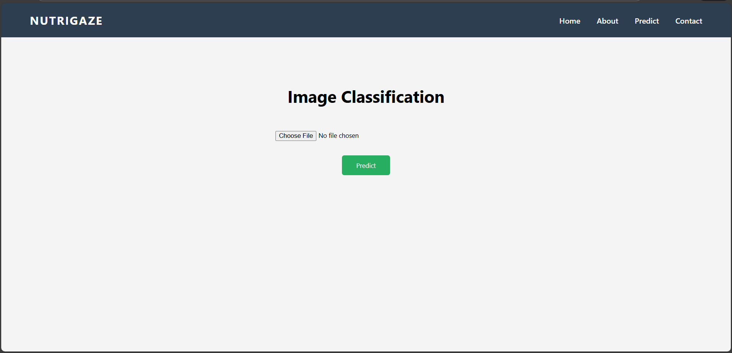

Output Display
After prediction:
- Fruit/Vegetable name is shown
- Status (Healthy / Rotten) is displayed
- Confidence percentage is shown
- Uploaded image preview is displayed

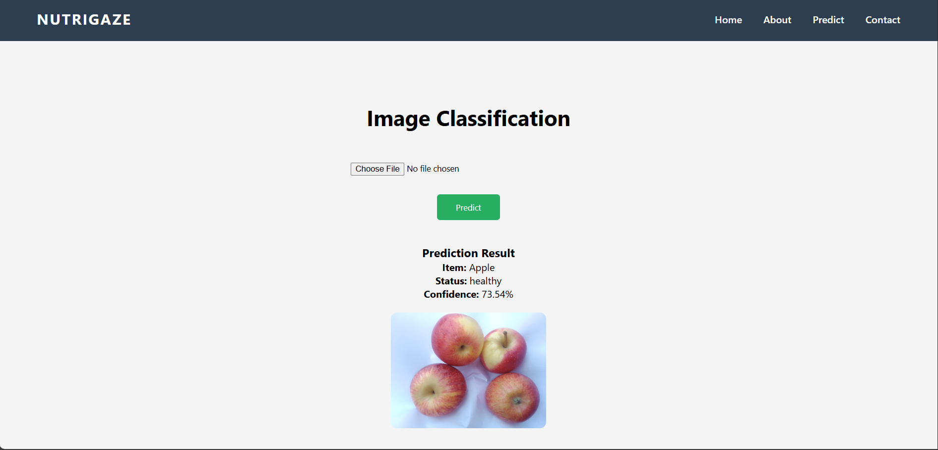
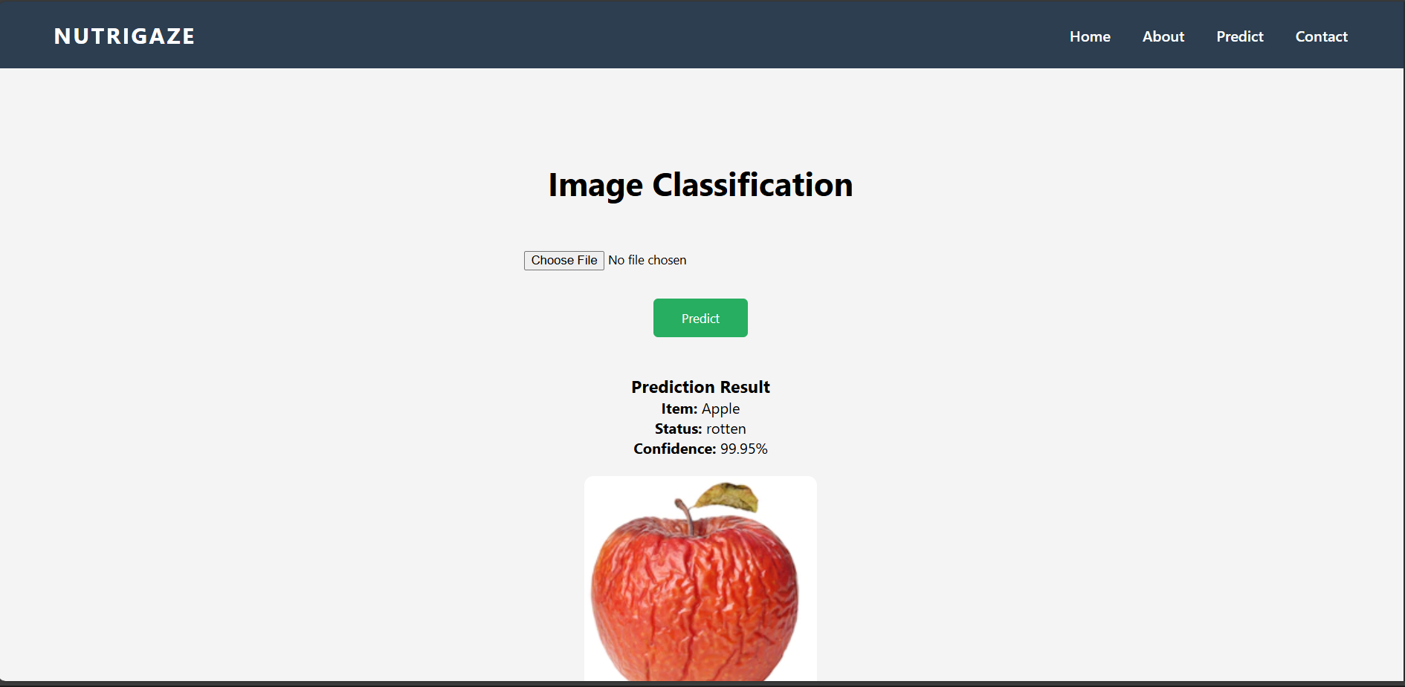

8. FEATURES OF THE PROJECT
- Deep Learning based image classification
- Modern web interface
- Real-time image prediction
- Displays confidence score
- User-friendly navigation
- Structured project architecture

9. FUTURE ENHANCEMENTS
- Mobile responsive UI
- Real-time camera detection
- Cloud deployment
- Database integration
- User authentication
- Model optimization for higher accuracy

10. CONCLUSION
NutriGaze successfully demonstrates the practical application of Artificial Intelligence in food quality monitoring. By leveraging Transfer Learning and the VGG16 architecture, the system achieves high accuracy in classifying fruits and vegetables as Healthy or Rotten.
This project highlights how AI can be used to reduce food waste, improve efficiency, and automate quality inspection processes in the agricultural and food industry.

11. DEVELOPER DETAILS
Project Name: NutriGaze – Smart Sorting System
Domain: Artificial Intelligence & Machine Learning
Project Type: Internship Project
Developer: KOILADA PAVITRA

